Ch 26 Numericals
Q1: During the 4.0 min a 5.0 A current is set up in a wire, how many (a) coulombs and (b) electrons pass through any cross sec tion across the wire’s width?
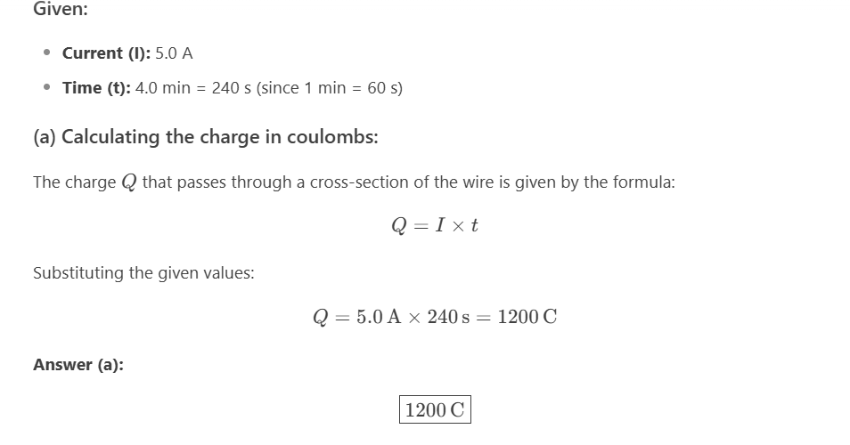
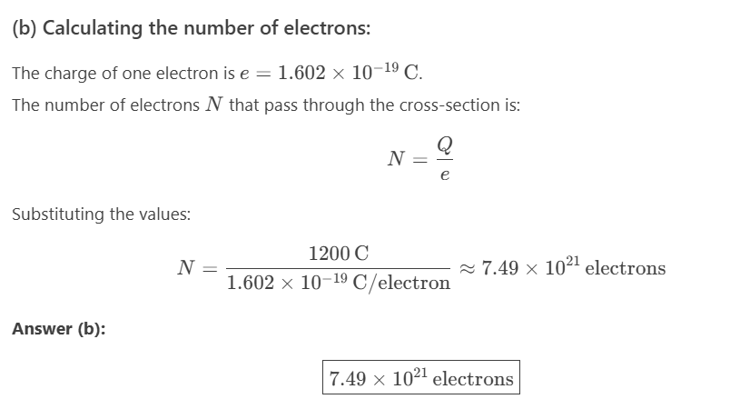
Q2: An isolated conducting sphere has a 10 cm radius. One wire carries a current of 1.000 002 0 A into it. Another wire carries a current of 1.000 000 0 A out of it. How long would it take for the sphere to increase in potential by 1000 V?
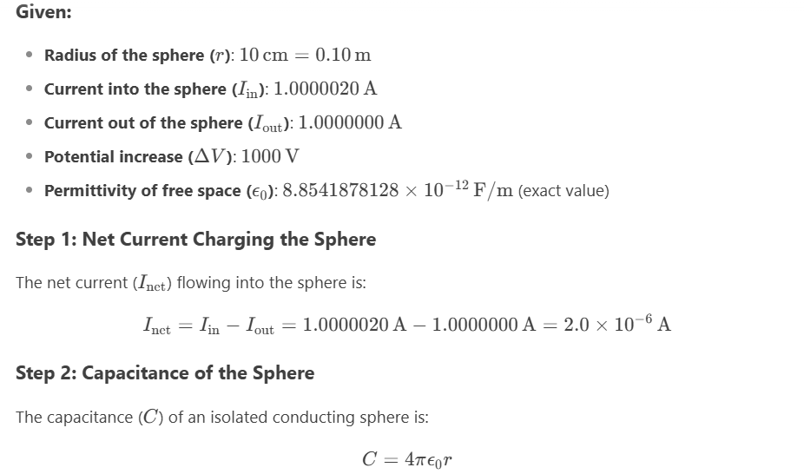
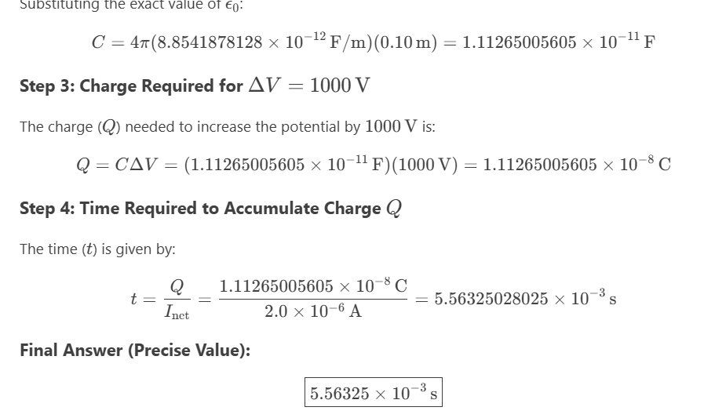
Q3: A charged belt, 50 cm wide, travels at 30 m/s between a source of charge and a sphere. The belt carries charge into the sphere at a rate corresponding to 100 mA. Compute the surface charge density on the belt.
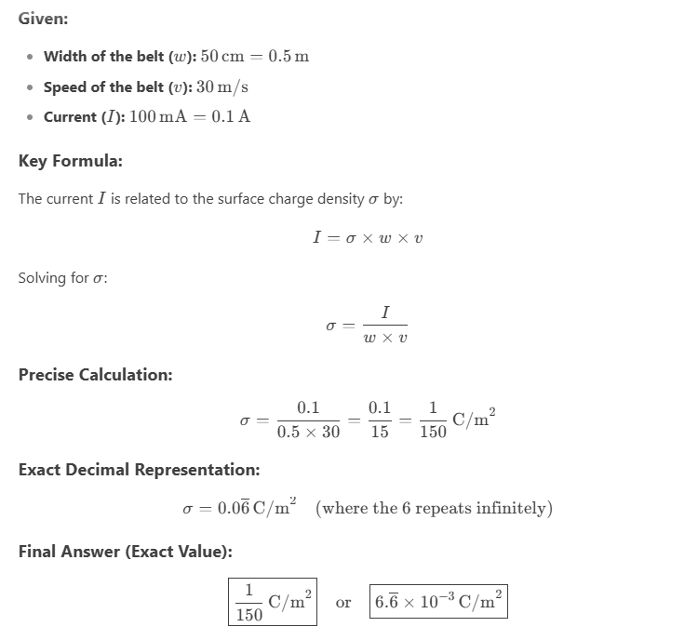
Current Density
Q5: A beam contains 2.0 108doubly charged posi tive ions per cubic centimeter, all of which are moving north with a speed of 1.0 105 m/s.What are the (a) magnitude and (b) direc tion of the current density J : ? (c) What additional quantity do you need to calculate the total current i in this ion beam?
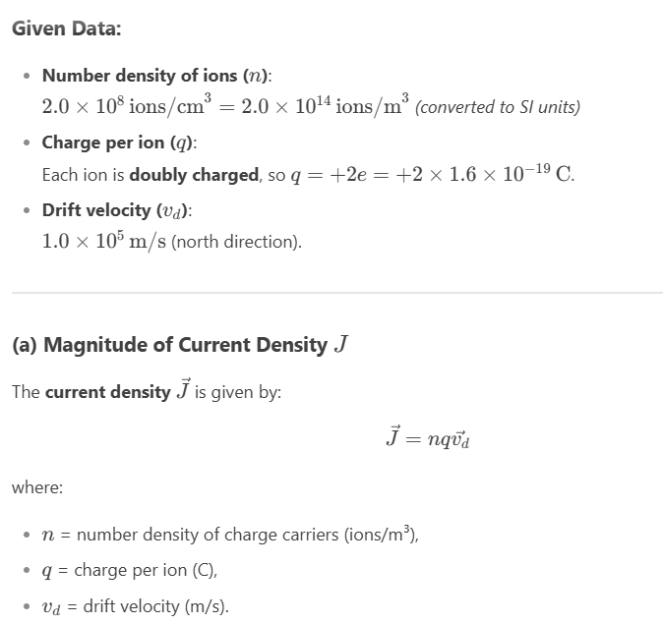
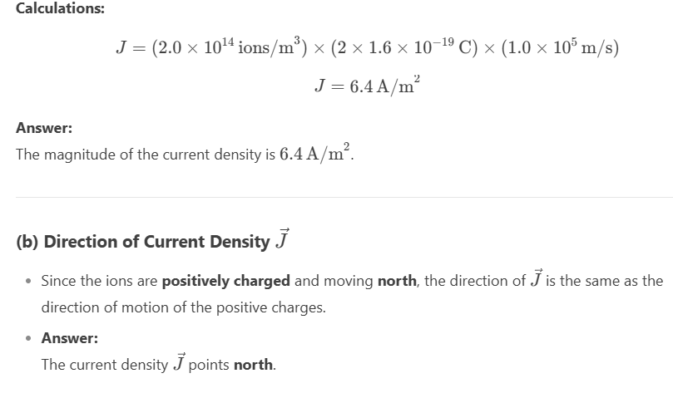
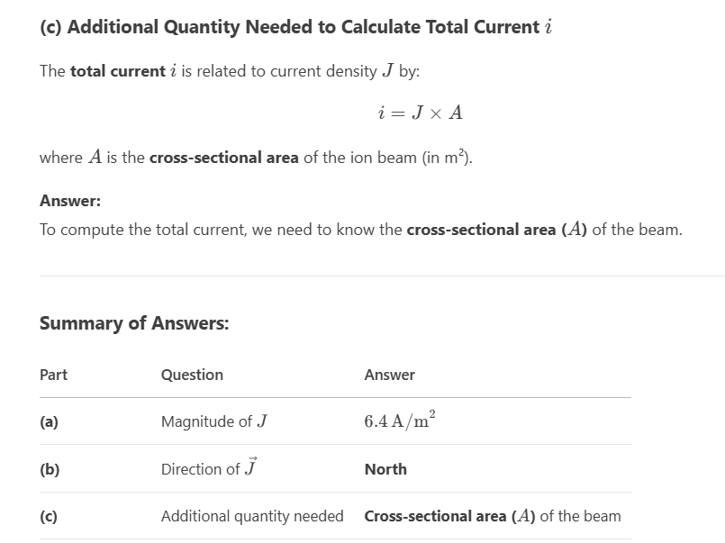
Q7: A fuse in an electric circuit is a wire that is designed to melt, and thereby open the circuit, if the current exceeds a predetermined value. Suppose that the material to be used in a fuse melts when the current density rises to 440 A/cm2.What diameter of cylindrical wire should be used to make a fuse that will limit the current to 0.50 A?
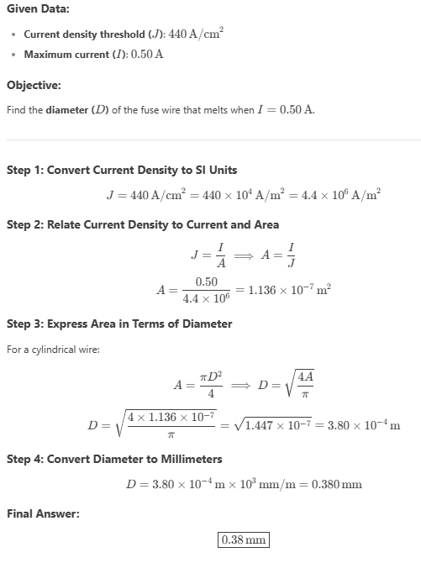
Q8: A small but measurable current of 1.2 10 10 A exists in a copper wire whose diameter is 2.5 mm.The number of charge carri ers per unit volume is 8.49 1028 m3.Assuming the current is uni form, calculate the (a) current density and (b) electron drift speed.
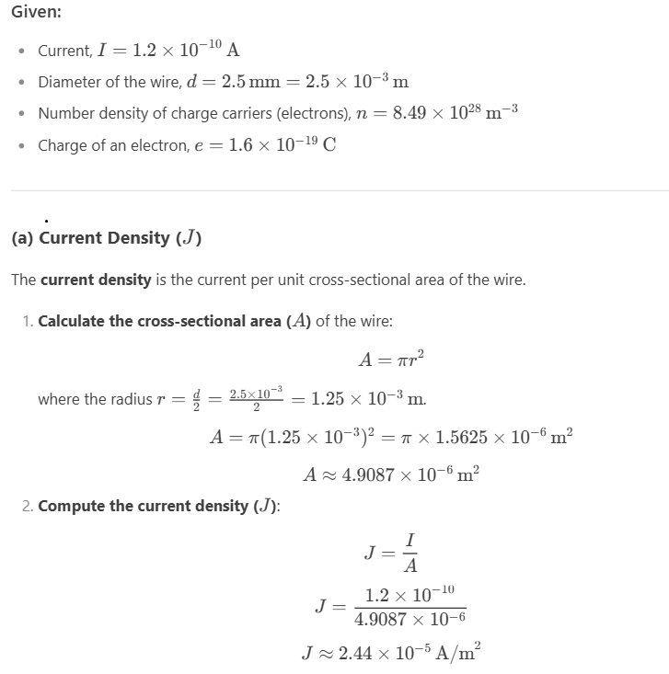
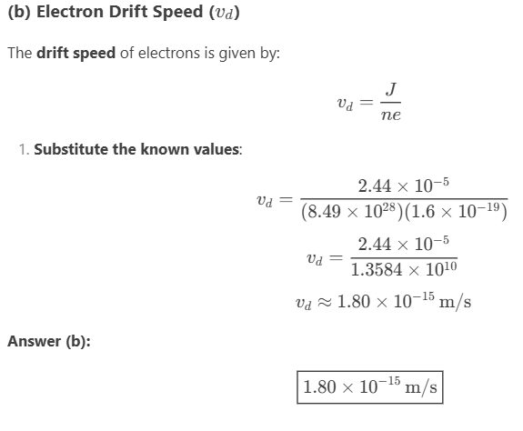
RESISTANCE AND RESISTIVITY:
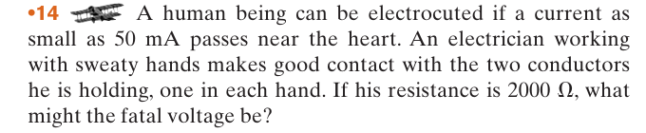
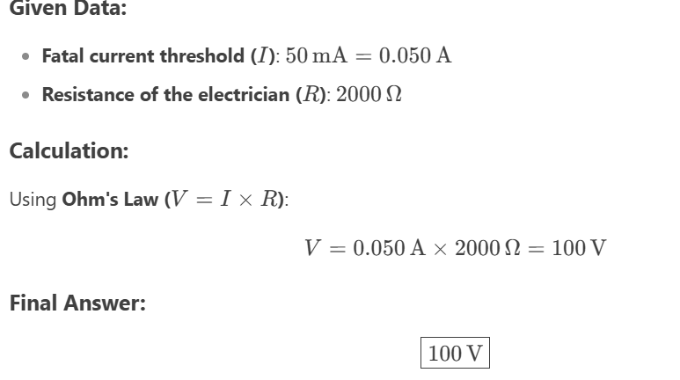
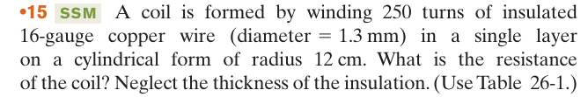
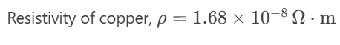
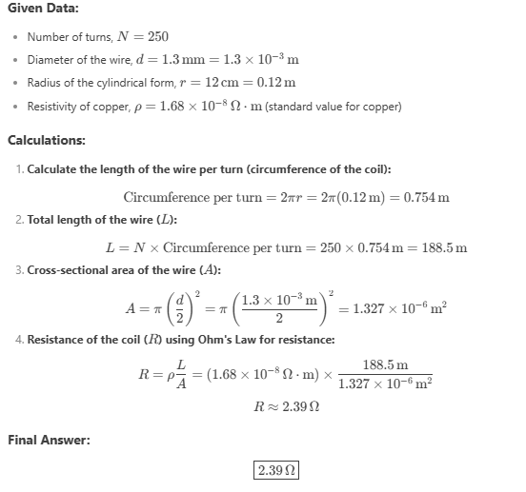
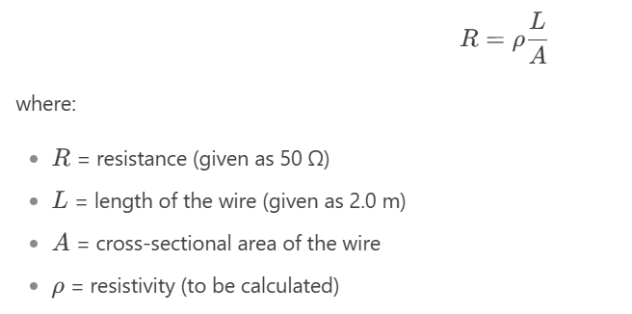
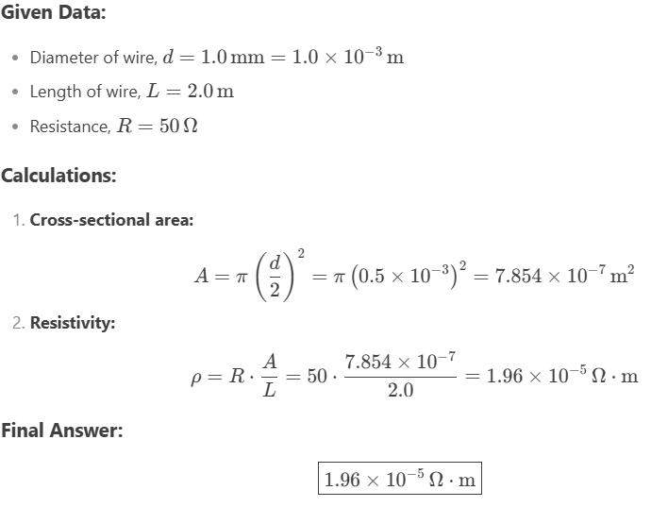
QUESTION:
